Please ensure you have also uploaded through your JLE account the following supplementary files:
- a brief autobiographical note on a separate sheet to the main body of the text
Your Name (First M. Last). Omit titles add degrees
Institution Name (University, Town, State)
Your ORCID
Provide full correspondence details here including e-mail
Correspondence concerning this article should be addressed to Ben Aroud, University of Bialystok, ul. M. Skłodowskiej-Curie 14, Białystok, Poland, 19-276. E-mail: baroud@gmail.com)
Contact details and academic affiliations for all co-authors should be submitted in this file. Also, please, identify who is to be the corresponding author. These details must match what appears on your manuscript.
Acknowledgments should be included in this file (acknowledgements / funding information in the main text should be removed for blind review).
Declaration of competing interests also should be presented in this file.
- Cover letter (see its form in Information for authors)

As part of the submission process you will be required to warrant that you are submitting your original work, that you have the rights in the work, that you are submitting the work for first publication in the Journal and that it is not being considered for publication elsewhere and has not already been published elsewhere, and that you have obtained and can supply all necessary permissions for the reproduction of any copyright works not owned by you.
Article type

Full Title of Your Paper

Author information has been removed for blind review

Abstract
Begin typing your abstract paragraph here. An abstract is a single paragraph, without indentation, that summarizes the key points of the manuscript in 200 to 300 words. The usual sections defined in a structured abstract are the Background, Methods, Results, and Conclusions. This paragraph should not be indented. Abstract should be accurate, nonevaluative, readable, and concise. This is the most important single paragraph in this paper.
Keywords: insert 5 to 10 keywords here, lowercase, separated by commas, no period after the keyword sequence. Note: The keywords are typed in regular font, not in italics

Introduction
This section discusses the results and conclusions of previously published studies, to help explain why the current study is of scientific interest.
The statement of the problem should be given in the introduction in a clear and concise manner. The background or rationale for the study is included here as well as a demonstration of how previous research is related to the study, together with its limitations. So, the bulk of the Introduction section is background literature on the topic. Try to provide the reader with enough information on the topic to be able to conclude that the research is important and that the hypotheses are reasonable. The last section of the Introduction states the purpose and the objectives of the research. Hypotheses are also included here at the end of this section. Hypotheses are written in past tense because they are connected with a finished study.
In APA any source you use in your paper must have an in-text citation. In APA these citations include the author’s last name and the year of the publication in parentheses (Aroud, 2017). If the source you are using does not identify an author, use a shortened version of the source title rather than the author name (E-Portfolios for Education, 2006).
Sections can have subsections with headings. For example, a Method section might have Participants, Materials, and Procedure subsections if there are enough details to explain to warrant such headings. Bold some headings. Below are examples.
APA 7.0 supports five levels of headings.

Heading Level 1

Heading Level 2
Text begins indented as a new paragraph.
Heading Level 3
Text begins indented as a new paragraph.
Heading Level 4. Text begins on the same line and continues as a regular paragraph.
Heading Level 5. Text begins on the same line and continues as a regular paragraph.
The heading styles are set in this document to correspond with those heading levels 1 through 5. The next heading is a Heading 1. It will be followed by a Heading 2.
E.g.

Materials and Methods

Participants
Text. Text. Text.

Assessments and Measures
Text. Text. Text.
First Heading 3 Level in the Section
Text. Text. Text.
Second Heading 3 Level in the Section
If you use one Heading 3, you should use a second, just like when you create an outline, if you have an “A” you should have a “B”
First Heading 4 Level in the Section. Text. Text. Text.
Second Heading 4 Level in the Section. If you use one Heading 4, you should use a second, just like when you create an outline, if you have an “A.” you should have a “B.”
First Heading 5 Level in the Section. Text. Text. Text. Text. Text. Text. Text. Text. Text. Text. Text. Text.
Second Heading 5 Level in the Section. If you use one Heading 5, you should use a second, just like when you create an outline, if you have an “A.” you should have a “B.”

Results
The goal of the Results section is to present the main findings of the research without deducing their meaning. Here, the grouped data and the results of the statistical analyses carried out are included. Figures, tables and graphs are also placed here, as well as a summary or description of the data. Information such as the subjects’ average scores or ratings and how the scores varied among the different groups should also be included in this section. The Results section should always be presented in a systematic way following the sequence of the Methods section on which the results are based (in other words - includes subsections that describe the answer to a particular experimental procedure that was elaborated in the Methods / refers to the experimental protocols described in the Methods section). It’s often helpful to use tables describing results, especially when the author has a lot of data to report (such as means and standard deviations) or is describing correlations. Sometimes it is helpful to remind the reader of the hypothesis before presenting each result. It is also a good idea to tell the reader what type of data analysis was done (e.g., correlation, ANOVA) before it is presented.

Outcome 1
Text. Text. Text.

Outcome 2
Text. Text. Text.

Discussion
The objective here is to provide an interpretation of your results and support for all of your conclusions, using evidence from your experiment (research) and generally accepted knowledge, if appropriate. Suggest future directions for research, new methods, explanations for deviations from previously published results, etc. Emphasize any theoretical or practical consequences of the results.
Open the Discussion section with a clear statement of the support or nonsupport for your original hypotheses, distinguished by primary and secondary hypotheses. If hypotheses were not supported, offer post hoc explanations. Similarities and differences between your results and the work of others should be used to contextualize, confirm, and clarify your conclusions. Results should also be commented in a theoretically meaningful way (How do the findings fit in with previous theory and literature? Are the results consistent or inconsistent with what has been found in the past? If they are inconsistent, how can it be explained?).
Do not simply reformulate and repeat points already made; each new statement should contribute to your interpretation and to the reader’s understanding of the problem.
Your interpretation of the results should take into account (a) sources of potential bias and other threats to internal validity, (b) the imprecision of measures, (c) the overall number of tests or overlap among tests, (d) the effect sizes observed, and (e) other limitations or weaknesses of the study. If an intervention is involved, discuss whether it was successful and the mechanism by which it was intended to work (causal pathways) and/or alternative mechanisms. Also, discuss barriers to implementing the intervention or manipulation as well as the fidelity with which the intervention or manipulation was implemented in the study, that is, any differences between the manipulation as planned and as implemented.
Acknowledge the limitations of your research and address alternative explanations of the results. Discuss the generalizability, or external validity, of the findings.
This critical analysis should take into account differences between the target population and the accessed sample. For interventions, discuss characteristics that make them more or less applicable to circumstances not included in the study, how and what outcomes were measured (relative to other measures that might have been used), the length of time to measurement (between the end of the intervention and the measurement of outcomes), incentives, compliance rates, and specific settings involved in the study as well as other contextual issues.
End the Discussion section with a reasoned and justifiable commentary on the importance of your findings. This concluding section may be brief or extensive provided that it is tightly reasoned, self-contained, and not overstated. In this section, you might briefly return to a discussion of why the problem is important (as stated in the introduction); what larger issues, those that transcend the particulars of the subfield, might hinge on the findings; and what propositions are confirmed or disconfirmed by the extrapolation of these findings to such overarching issues.
Include limitations of the study. Describe the ways in which the internal or external validity of the study may have been compromised. Was the sample biased? Were the measures problematic? Think about what you would do different next time if you conducted a similar study. Future research ideas are often discussed when limitations are discussed.

Conclusion
Conclusion should be the best part of your paper. A conclusion should: (1) stress the importance of the thesis statement, (2) give the essay a sense of completeness, and (3) leave a final impression on the reader.
Conclusion describes the implications of findings to theory and practice, highlight practical applications of findings, gives some additional directions for future research. Direct answers to the original questions or hypotheses are included, in other words, the verification of the hypotheses goes here. The answers to the questions or the hypotheses must be explained, supported and defended with results. This explanation should consider the conflicting results, unexpected findings and discrepancies with other research. It is relevant to include the implications of the study, a comparison with previous research, innovations and the contribution of the study to new developments. Suggestions for further research, a brief statement on the limitations of the project and any pedagogical implications the paper may indicate.

Acknowledgments
Acknowledgements, funding information and declaration of competing interests have been removed for blind review.
Conflict of interests
The authors declare that they have no conflict of interest.

References
The relevant number of the in-text cited works is at least 30. And at least half of them should go Scopus / WoS indexed and newly published. The use of good references throughout the paper gives the work credibility.
If your reference has a DOI, include that DOI (It is MANDATORY). Please, use the following doi format http://dx.doi.org/10.1037/rmh0000008
Herbst, D. M., Griffith, N. R., & Slama, K. M. (2014). Rodeo cowboys: Conforming to masculine norms and help-seeking behaviors for depression. Journal of Rural Mental Health, 38, 20–35. http://dx.doi.org/10.1037/rmh0000008

Reference management software. Some reference template available in many of the most popular reference management software products. We recommend Mendeley. Users of Mendeley Desktop can easily install the reference style for this journal by clicking the following link: http://open.mendeley.com/use-citation-style/international-journal-of-educational-research. When preparing your manuscript, you will then be able to select this style using the Mendeley plug-ins for Microsoft Word or LibreOffice.

Aroud, B. H., Breck, P. T., & Falkone, R. M. (2016). Title of journal article. Journal of Research in Personality, 13, 254-276. http://dx.doi.org/10.1016/0032-026X.56.6.895
B’Markone, S. O. (2017). Modern education: Questions and answers. Journal of Language and Education, 4(3), 55-79.
Cranch, B. E., Aroud, B. P., & Falkone, R. (1999). Technology in modern life. Pearson.
Aroud, B. E. (2009). Words. In The new encyclopedia Britannica (vol. 38, pp. 745-758). Penguin.
Aroud, B. E. (2017). Words in articles. In A. Fallone (Ed.), Research projects (pp. 745-758). Penguin.
Cranch, B. R., & Falkone, A. C. (2011). Science and education. In P. Z. Albert, R. Brings & J. H. Cramm (Eds.), Research papers evaluation (pp. 123-256). Simon & Schuster.
Bennahmiasm, J.-L., & Roche, A. (1992). Des verts de toutes les couleurs: Histoire et sociologie du mouvement ecolo [Greens of all colours: History and sociology of the ecology movement]. Albin Michel.
Piaget, J. (1969). The psychology of the child (H. Weaver, Trans.). Basic Books.
Abramson, M. (2004, March 1). This is how to cite an online news article. The Washington Post. http://www.washingtonpost.com/dir/subdir/2014/05/11/a-d9-11e3_story.html
Considine, M. (1986). Australian insurance politics in the 1970s: Two case studies (Unpublished doctoral dissertation). University of Melbourne, Melbourne, Australia.

For all other cases (e.g., references to websites, reports, sources in languages other than English, unpublished manuscripts, etc., please refer to the APA manuscript style manual, 7th edition or Reference list section in Information for authors (https://jle.hse.ru/ref). You may find the APA style blog useful for additional information (http://blog.apastyle.org). All references need to be in APA manuscript style before the manuscript can go into copyediting and will be returned to the author if the formatting is not complete.

Common peculiarities are indicated below
References
Aroud, B. H., Breck, P. T., & Falkone, R. M. (2016). Title of the article. Journal of Research in Personality, 13, 254-276. doi:10.1016/0032-026X.56.6.895

B’Markone, S. O. (2017). Modern education: Questions and answers. Journal of Language and Education, 4(3), 55-79.

Cranch, B. E., Aroud, B. P., & Falkone, R. (1999). Technology in modern life (7th ed.). Pearson.

Aroud, B. E. (2009). Words. In The new encyclopedia Britannica (vol. 38, pp. 745-758). Penguin. http://dx.doi.org/10.1016/0032-026X.56.6.895

Aroud, B. E. (2017). Words in articles. In A. Fallone (Ed.), Research projects (2nd ed., pp. 745-758). Penguin.
Cranch, B. R., & Falkone, A. C. (2011). Science and education. In P. Z. Albert, R. Brings & J. H. Cramm (Eds.), Research papers evaluation (pp. 123-256). Simon & Schuster.
Editor, J. J., Editor, A. A., & Editor, P. P. (Eds.). (2012). Book title: And subtitle. Routledge.
Bennahmiasm, J.-L., & Roche, A. (1992). Des verts de toutes les couleurs: Histoire et sociologie du mouvement ecolo [Greens of all colours: History and sociology of the ecology movement]. Albin Michel.
Piaget, J. (1969). The psychology of the child (H. Weaver, Trans.). Basic Books.
Abramson, M. (2004, March 1). This is how to cite an online news article. The Washington Post. http://www.washingtonpost.com/dir/subdir/2014/05/11/a-d9-11e3_story.html
Considine, M. (1986). Australian insurance politics in the 1970s: Two case studies [Unpublished doctoral dissertation]. University of Melbourne.

Appendix
If your paper only has one appendix, label it "Appendix" (without quotes.) If there is more than one appendix, label them "Appendix A," "Appendix B," etc. (without quotes) in the order that each item appears in the paper. In the main text, you should refer to the Appendices by their labels.
The actual format of the appendix will vary depending on the content; therefore, there is no single format. In general, the content of an appendix should conform to the appropriate APA style rules for formatting text
Each appendix must have a capitalised title.
In the text, refer to appendices by their labels:
“… produced the same results for both studies (see Appendices A and B for complete proofs).”
Begin each appendix on a separate page.
Place the label and title of each appendix at the top of the page, centered, using normal capitalization. Label first, title second.
E.g.

APPENDIX A

EXERCISES USED IN THE COURSE

Footnotes
1Add footnotes, if any. To format a footnote reference, select the number and then, on the Home tab, in the Styles gallery, click Footnote Reference. The body of a footnote, such as this example, uses the Normal text style.
Only scientific materials should be included into Reference list. For other sources use Footnotes.
Use footnotes to cite sources which are not scientific or for explanatory (content) notes or copyright permission. Content footnotes contain information that supplements the text but would be distracting or inappropriate to include in the body of the paper. In other words, such footnotes provide important information that is a tangent to what you are discussing in your paper.
The footnote should only express one idea. If it is longer than a few sentences, then you should consider putting this information in an appendix. Most authors do not use footnotes because they tend to be distracting to the readers. If the information is important, authors find a way to incorporate it into the text itself or put it in an appendix.

Diagrams, Formulas, Special Characters
Submit diagrams and complex formulas as images (instead of importing them from other software or by using the Word formula editor). Do not include special characters as miniature images. Instead, use designated Word fonts (e.g., Symbol) or the Word Symbol Function under “Insert > Symbol”.
Text within diagrams must be in Times New Roman font (exceptions: symbols not available with Times New Roman), between 8 and 12 point.

Tables
APA Style tables have the following basic components:
- number: The table number (e.g., Table 1) appears above the table title and body in bold font. Number tables in the order in which they are mentioned in your paper.
- title: The table title appears one double-spaced line below the table number. Give each table a brief but descriptive title, and capitalize the table title in italic title case.
- headings: Tables may include a variety of headings depending on the nature and arrangement of the data. All tables should include column headings, including a stub heading (heading for the leftmost, or stub, column). The heading “Variable” is often used for the stub column if no other heading is suitable. Some tables also include column spanners, decked heads, and table spanners; these are described in the Publication Manual. Center column headings and capitalize them in sentence case.
- body: The table body includes all the rows and columns of a table (including the headings row). A cell is the point of intersection between a row and a column.
  - The table body may be single-spaced, one-and-a-half-spaced, or double-spaced.
  - Left-align the information in the leftmost column or stub column of the table body (but center the heading).
  - In general, center information in all other cells of the table. However, left-align the information if doing so would improve readability, particularly when cells contain lots of text.
- note: Three types of notes (general, specific, and probability) appear below the table as needed to describe contents of the table that cannot be understood from the table title or body alone (e.g., definitions of abbreviations, copyright attribution, explanations of asterisks used to indicate p values). Include table notes only as needed. All of them must be placed below the table in that order.
General notes explain, qualify or provide information about the table as a whole. Put explanations of abbreviations, symbols, etc. here.
Specific notes explain, qualify or provide information about a particular column, row, or individual entry. To indicate specific notes, use superscript lowercase letters (e.g. ª, ^{b}, ^{c}), and order the superscripts from left to right, top to bottom. Each table’s first footnote must be the superscript ª.
ª n = 654. ^{b} One participant in this group was marked as a potential leader.
Probability notes provide the reader with the results of the tests for statistical significance. Asterisks indicate the values for which the null hypothesis is rejected, with the probability (p value) specified in the probability note. Such notes are required only when relevant to the data in the table. Consistently use the same number of asterisks for a given alpha level throughout your paper.
*p < .05. **p < .01. ***p < .001

If you are adapting or reprinting a table or figure that was originally published by someone else, you will need to provide a copyright statement beneath the table or figure as well as include a corresponding reference entry.
Adapted from “Skills and Competencies in Higher Education and Beyond,” by L. Raitskaya, & E. Tikhonova, 2019, Journal of Language and Education, 5(4), p. 7 (https://doi.org/10.17323/jle.2019.10186). Copyright 2019 by National Research university Higher School of Economics.

Table 1
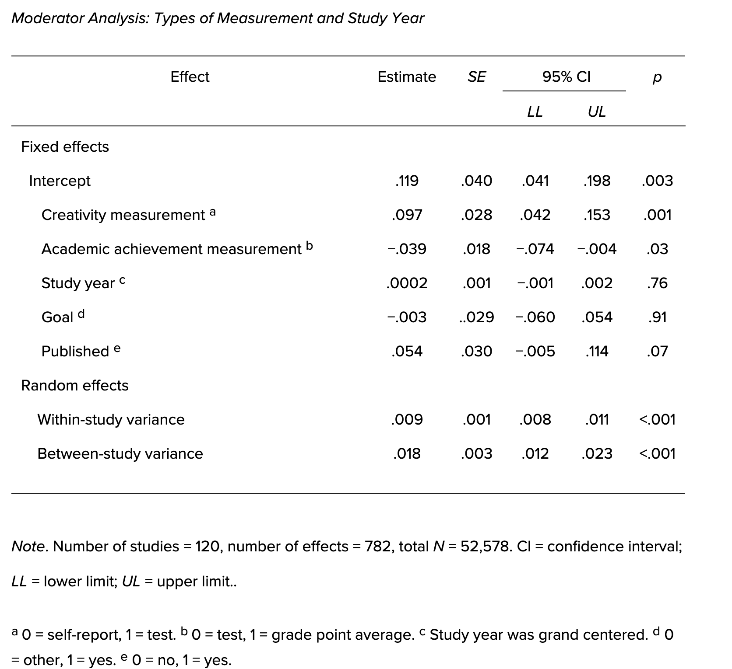

Each table should be displayed with a brief explanatory title
You must include a caption beneath the table
All explanatory text appears in a table note that follows the table, such as this one.

Please submit tables as editable text and not as images. Tables should be placed next to the relevant text in the article. Number tables consecutively in accordance with their appearance in the text and place any table notes below the table body. Be sparing in the use of tables and ensure that the data presented in them do not duplicate results described elsewhere in the article.
Tables should only include borders and lines that are needed for clarity (i.e., between elements of a decked head, above column spanners, separating total rows, etc.). Do not use vertical borders, and do not use borders around each cell. Spacing and strict alignment is typically enough to clarify relationships between elements.

Figures
APA Style figures have the following basic components:
- number: The figure number (e.g., Figure 1) appears above the figure title and image in bold font. Number figures in the order in which they are mentioned in your paper.
- title: The figure title appears one double-spaced line below the figure number. Give each figure a brief but descriptive title, and capitalize the figure title in italic title case.
- image: The image portion of the figure is the graph, chart, photograph, drawing, or other illustration itself. If text appears in the image of the figure (e.g., axis labels), use a sans serif font between 8 and 14 points.
- legend: A figure legend, or key, if present, should be positioned within the borders of the figure and explains any symbols used in the figure image. Capitalize words in the figure legend in title case.
- note: Three types of notes (general, specific, and probability) can appear below the figure to describe contents of the figure that cannot be understood from the figure title, image, and/or legend alone (e.g., definitions of abbreviations, copyright attribution, explanations of asterisks use to indicate p values). Include figure notes only as needed.

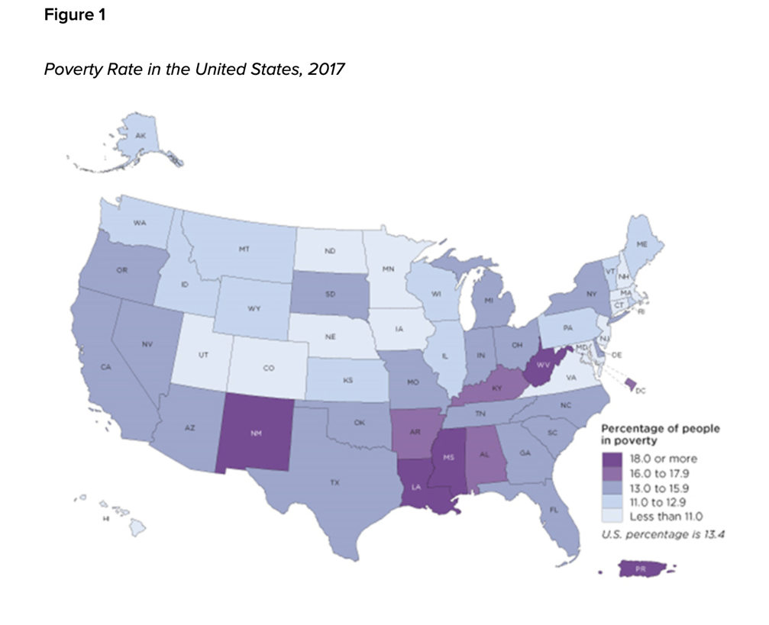
Note. The map does not include data for Puerto Rico. Adapted from 2017 Poverty Rate in the United States, by U.S. Census Bureau, 2017 (https://www.census.gov/library/visualizations/2018/comm/acs-poverty-map.html). In the public domain.

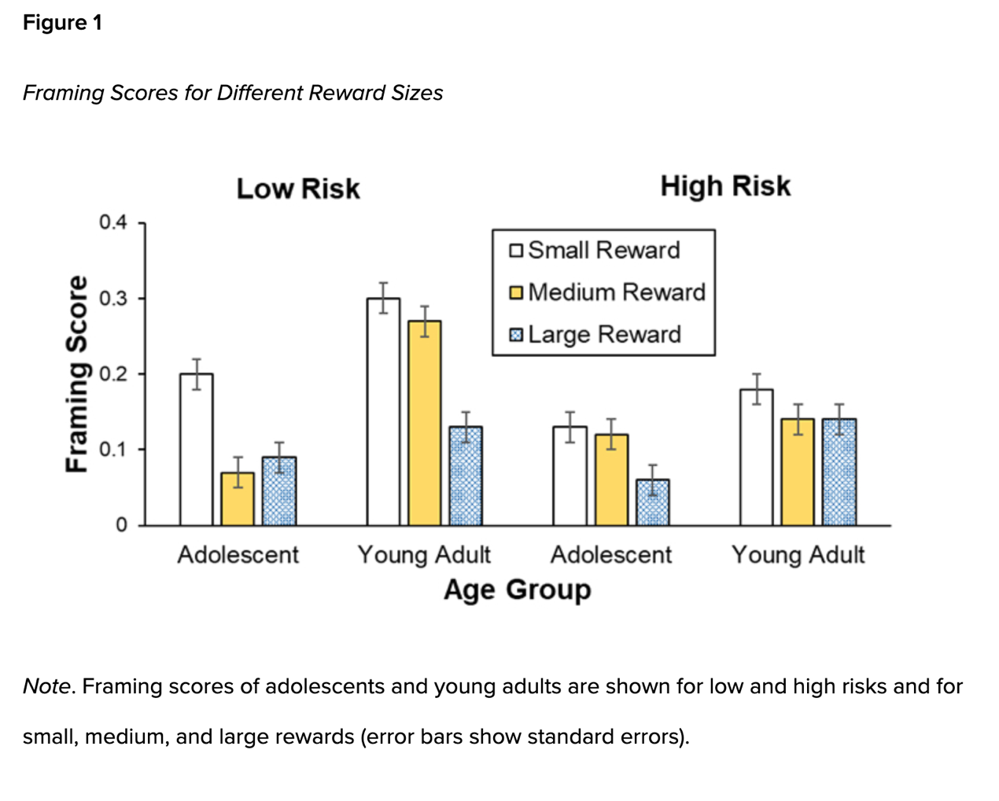 Principles of Figure Creation
The most important principle to follow when creating a figure is to present information in a way that is easy for readers to understand. Provide sufficient information in the figure itself so that readers do not need to read the text to understand it.
When creating a figure, ensure you meet the following standards:
- images are clear
- lines are smooth and sharp
- font is legible and simple
- units of measurement are provided
- axes are clearly labeled
- elements within the figure are clearly labeled or explained
Use graphics software to create figures in APA Style papers. For example, use the built-in graphics features of your word-processing program (e.g., Microsoft Word or Excel) or dedicated programs such as Photoshop or Inkscape.
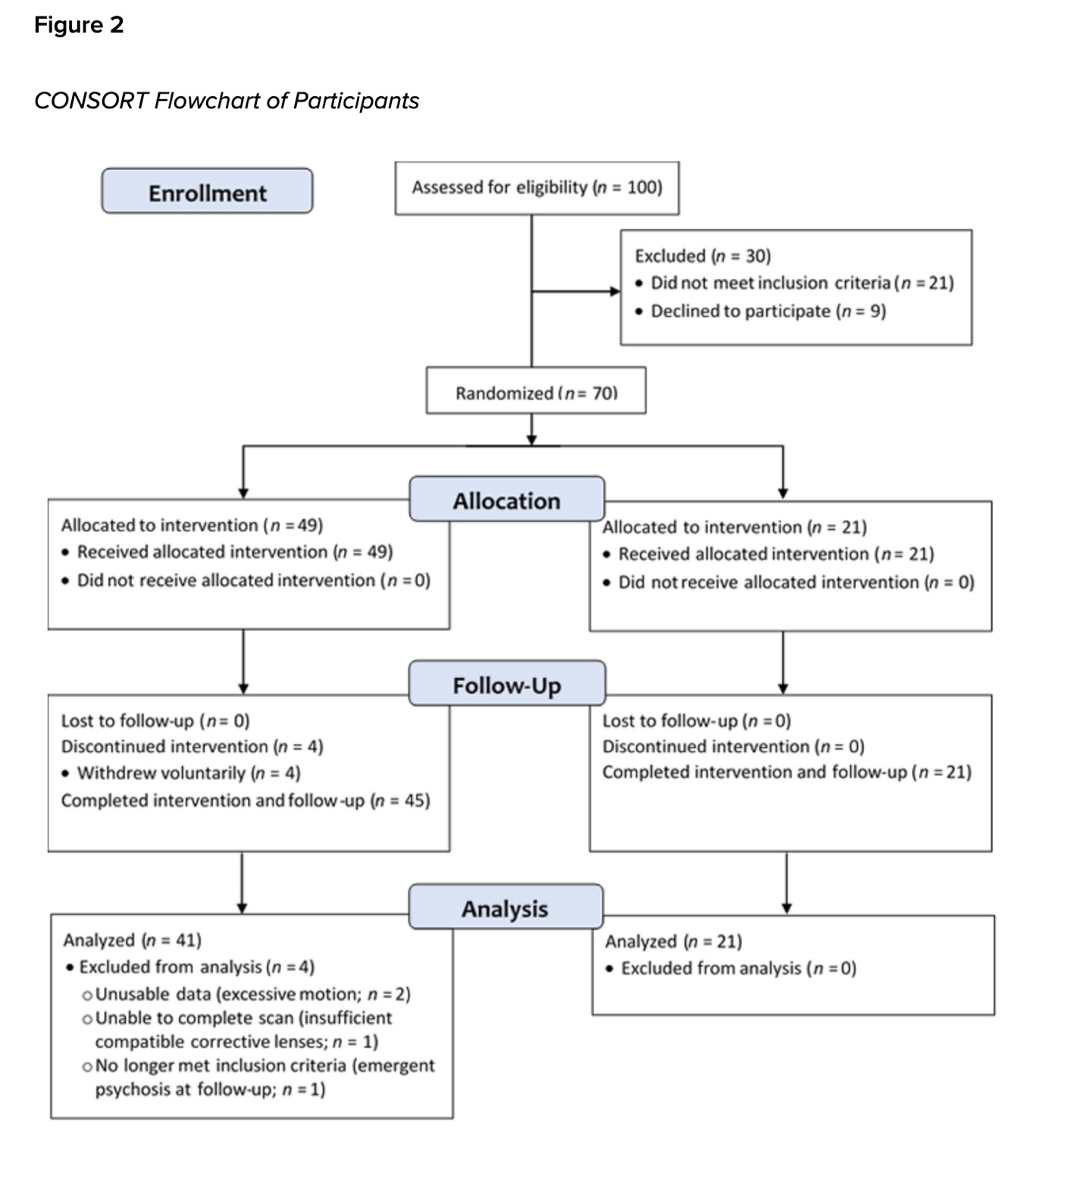
For more information about all elements of APA formatting, please consult the APA Style Manual, 7th Edition.

Text. Text. Text.

